Project Planning Phase
Project Planning
Date | November 2, 2025
Team ID | F53C03230D9D3649CD4402B24FF15FEB
project Name | Educational organization using ServiceNow

Project: Educational Management System Using ServiceNow
1. Project Goal:
To design, develop, and implement a custom application within ServiceNow to automate and streamline the student admission and progress tracking processes for an educational organization.
2. Project Scope:
- In Scope:
  - Creation of three custom tables: Salesforce (parent), Admission (child), Student Progress.
  - Configuration of all necessary fields, including choice lists and reference fields.
  - Creation of user-friendly forms using Form Design and Form Layout.
  - Implementation of a Process Flow on the Admission form.
  - Setup of auto-numbering (SAL...) for all records.
  - Development of client scripts for:
    - Auto-population of data (Pincode -> Address, Admission Number -> Student Details).
    - Automated calculations (Total, Percentage, Result).
    - Form validation and read-only fields.
- Out of Scope:
  - Teacher or staff management.
  - Class scheduling or attendance tracking.
  - Student or parent-facing portal.
  - Integration with any real external financial systems.
3. Milestones and Timeline (Example 4-Week Sprint):
Week | Milestone | Key Tasks
Week 1 | Foundation & Data Model | - Set up ServiceNow PDI.  - Create Update Set.  - Define and build all three tables (Salesforce, Admission, Student Progress).  - Configure all table columns, references, and choice lists.
Week 2 | User Interface (UI) | - Configure Form Layouts for all tables (including dot-walking).  - Create user-friendly Form Designs for all tables (2-column layouts, sections).  - Implement Number Maintenance for "Admin Number".
Week 3 | Business Logic & Process | - Build the Process Flow for the Admission table.  - Develop all Client Scripts for the "Admission Table" (Auto-populate, Pincode Update).  - Develop all Client Scripts for the "Student Progress Table" (Disable Fields, Total, Percentage, Result).
Week 4 | Testing & Go-Live | - Conduct Performance and User Acceptance Testing.  - Test all calculation and auto-population scripts.  - Prepare final Result demonstration.  - Mark Update Set as "Complete".
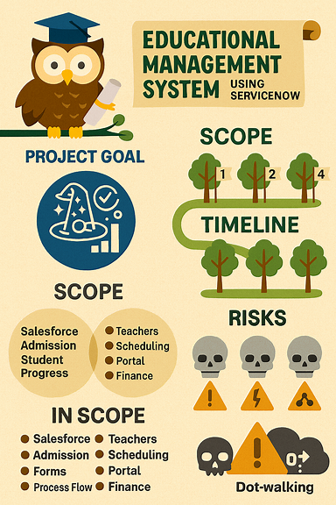
4. Risks:
- Risk 1: Client script calculation logic is incorrect.
  - Mitigation: Test each calculation script individually (Total, Percentage, Result) and then test them as a chain.
- Risk 2: Table inheritance (Salesforce -> Admission) is set up incorrectly.
  - Mitigation: Verify that fields from the Salesforce table are available on the Admission form before building UI.
- Risk 3: Dot-walking on the Student Progress form fails to pull data.
  - Mitigation: Ensure the Admission Number field is a proper Reference Field and that permissions are correct.

